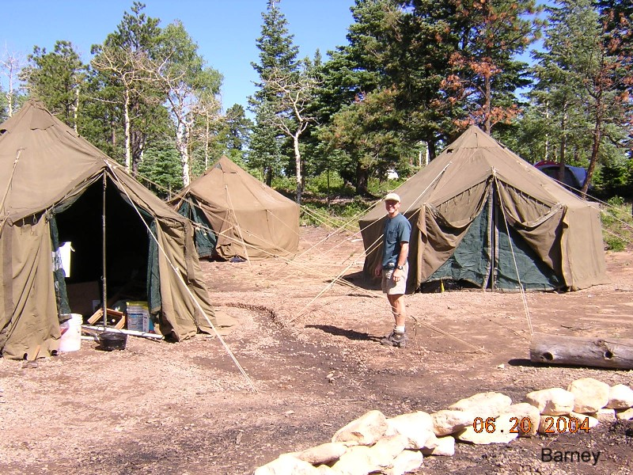
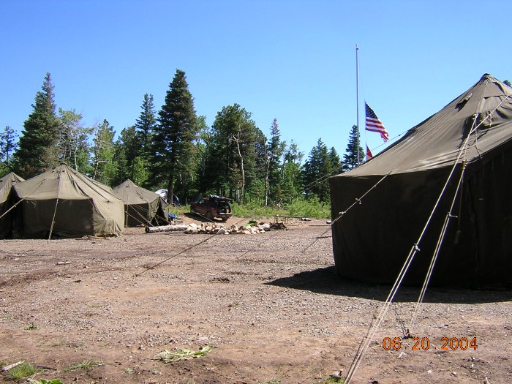
A Summer camp is a very fun week-long adventure in places like The Spanish Peaks in Colorado. While at summer camp the scouts work on merit badges, outdoor skills, games, hikes and other outdoor activities led by our trained Merit Badge Counselors. When Troop 68 moves into our summer camp location we move in with the skill and equipment of a military MASH unit. We look forward to spending time in the summer in the cool mountain air. Hopefully we will see you there this year.

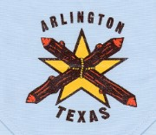
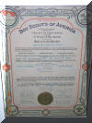
Troop 68 started in October of 1929 and has been going strong for over 75 years. We have a strong alumni association and over 45 adults assisting the troop in all aspects of our scouting program. We have generations of scouts membership, parents who were scouts in Troop 68, have brought their own sons into the troop.

www.Troop68.org

TROOP



YOU ARE INVITED!

We meet every Monday night
7:30 – 9:00 P.M.

TROOP 68
407 N. Mesquite
Arlington, Tx.
76011-7128

GPS: North 32 degrees, 44.472 minutes
West -097 degrees, 06.325 minutes.

For more information contact Scoutmaster:
Eric McGinnis
214-274-5676

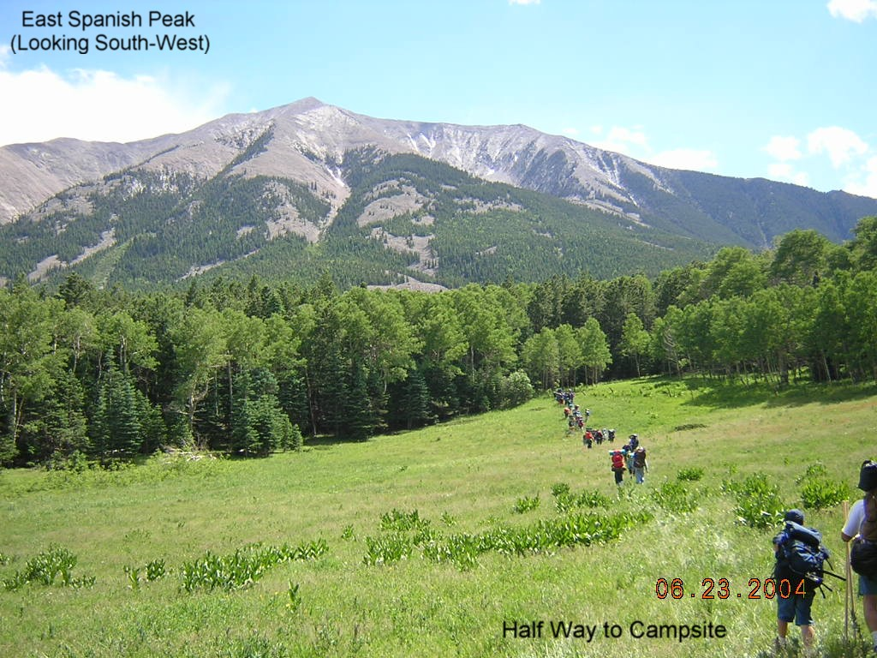

TROOP


Community Service - Camping
Backpacking - Rock Climbing - Rappelling
Rifle & Shotgun Shooting – Boating Canoeing – Sailing - Fishing - Archery
Swimming - Outdoors Programs
Merit Badges - Leadership Development


www.Troop68.org

YOU are INVITED to visit Troop 68
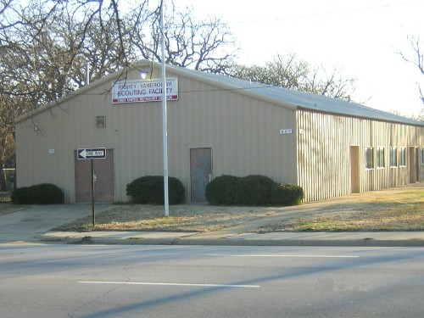
We meet every Monday night
7:30–9:00 P.M.

We meet regularly in our own building that was donated by one of our own Eagle Scouts. The Scout Hut is located across the street from our charter organization, the First United Methodist Church of Arlington.

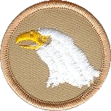
The meetings are led by the SPL (Senior Patrol Leader) and assisted by the boys in Staff. The SPL will conduct the meeting, make announcements, call for the Scoutmaster when needed and conduct the meeting or turn it over to one of our many program presenters.

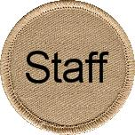
The scouts choose the meeting themes. The themes may be preparing for the next camp out, equipment care, snake exhibitions, knife and saw use, Indian Lore, ham radio, falconry, home improvement, first aid, outdoor skill development, boat safety, and the list goes on and on with whatever activities that the boys decide to have.

The scouts are called back to order by the staff and SPL, the SPL makes any closing announcements. The assigned patrol conducts the closing.

Troop 68 is a boy led troop. With guidance from the adult leaders, the older more experience boys plan the meetings and campouts. The Senior Patrol Leader and his staff run the weekly meetings. Boys naturally learn more leadership skills from each other and with hands on learning and experience, the boys will succeed. The scouts learn leadership skills as they advance and mature, earning their way into Staff and to become the new leaders of the troop.

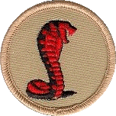

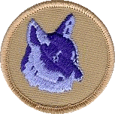
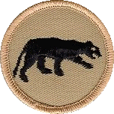
Each scout becomes a member of the patrol that they are assigned to. The members of the patrol elect leaders and work together to help each other earning ranks and developing leadership skills. Each patrol works as a unit within the troop competing against other patrols, learn to function as a team, learning skills, camping together, planning and cooking meals and having fun.


While education and fun are the basis of our Advancement Program, personal growth is the prime consideration in our Advancement Program. Troop 68 has a strong alumni group and an outstanding pool of Merit Badge Counselors. We create strong leaders.

Troop 68 has graduated over 150 Eagle Scouts. Our dedication to providing the best possible program for the boys ensures the boy will be successful in his adult life. Our Eagles come back to help the Troop and encourage the boys to be their best.

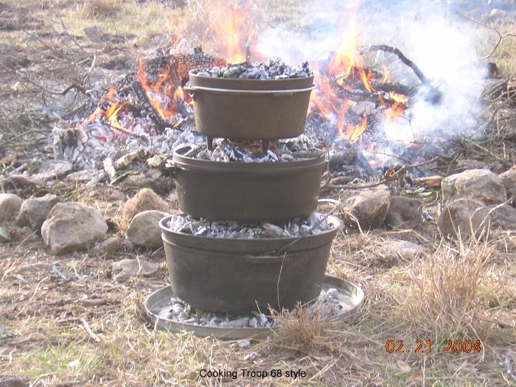
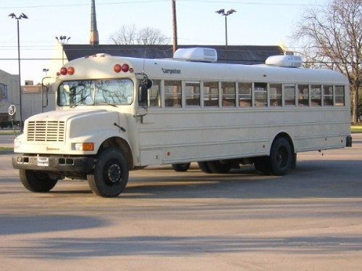
Troop 68 has a lot of resources that make the scouting experience more enjoyable. We have the Scout Hut for our meetings, with storage rooms, our own troop bus, troop trailers, sail boats, canoes, back packs, tents for backpacking, tents for summer camp, all sorts of camping gear, chuck boxes, lanterns, stoves for camping, and stoves for backpacking, we have enough equipment and resources that the scout only needs to provide their own personal equipment.

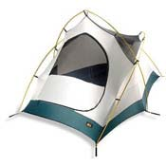
We go on a campout once per month, leaving on Fridays returning on Sunday afternoons. Each campout is based on a theme such as waterfront fun, fishing, rock climbing, canoeing, backpacking and other fun themes that the boys are interested in attending.

